# Create MySQL database.

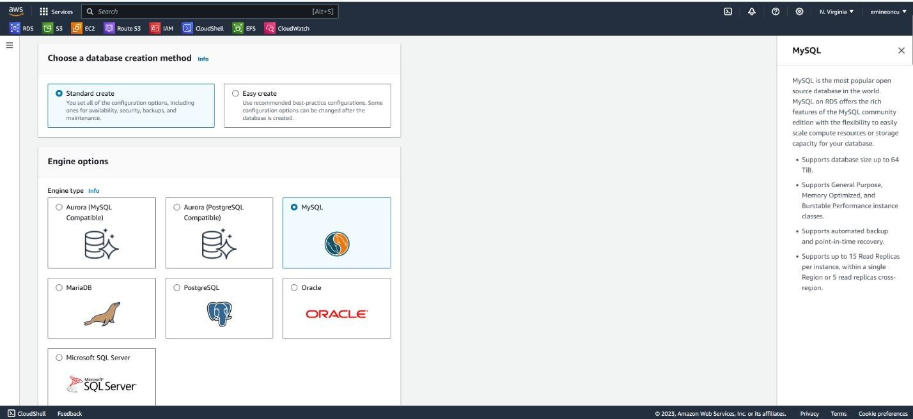

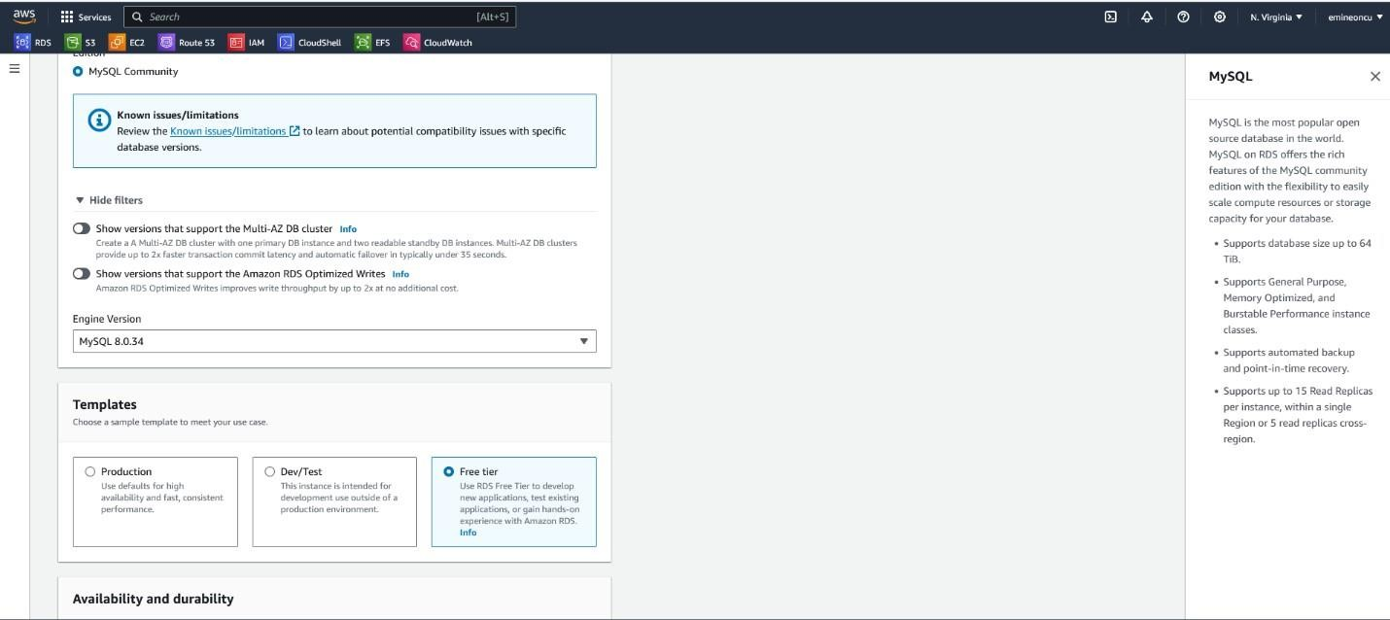

* ***Selected the Free Tier option for MySQL DB***

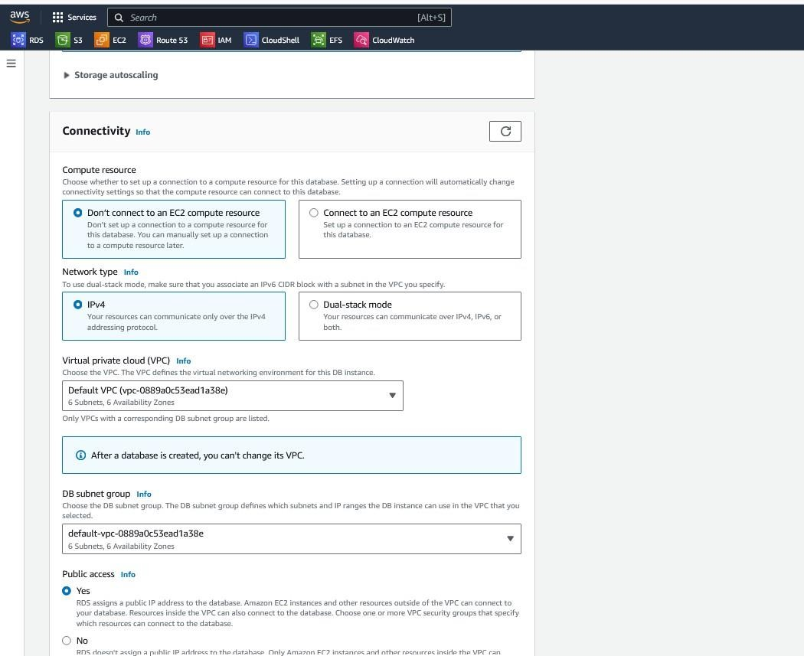

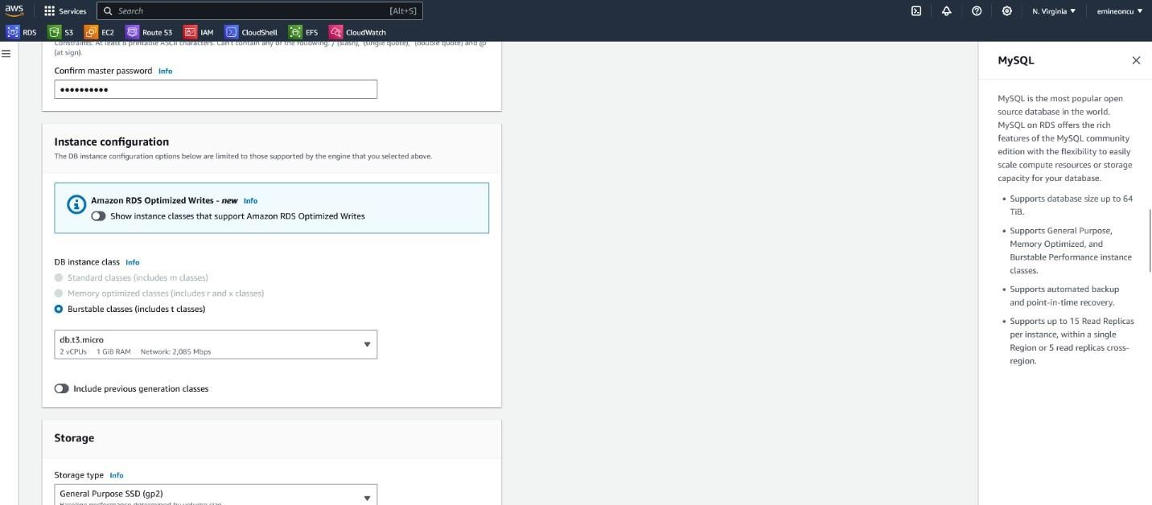

* ***I selected the underlying EC2 instance which is available within the Free Tier***
* ***I will be creating a new security group and make the database accessible via username/password credentials.***

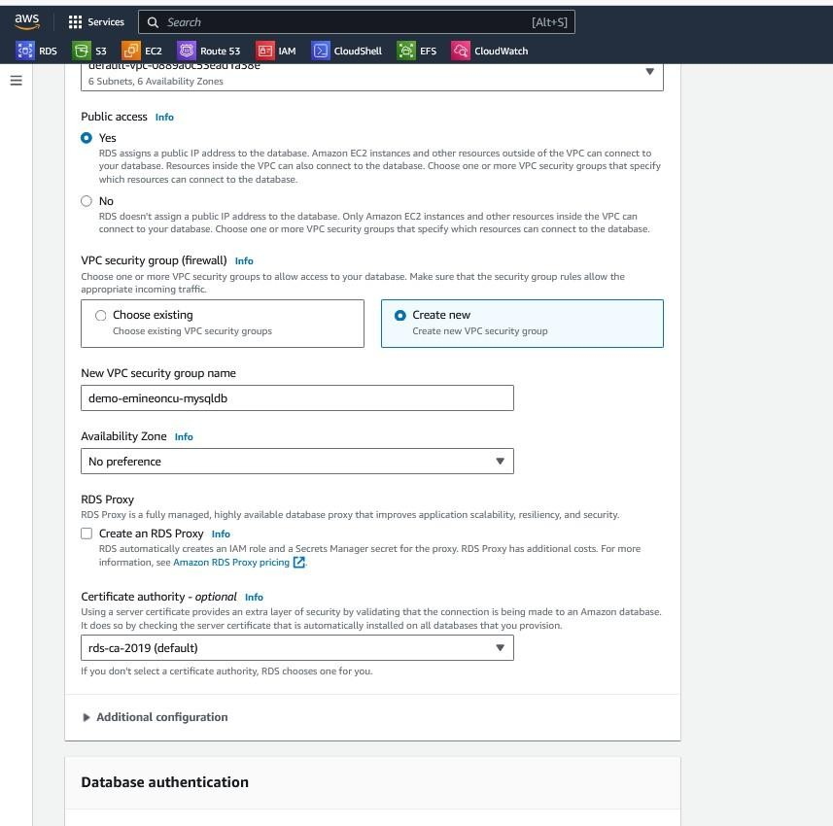

* ***This database will have Public access so I can connect to it from DB Visualizer Client on my local machine. I will be using the default VPC and Subnet.***

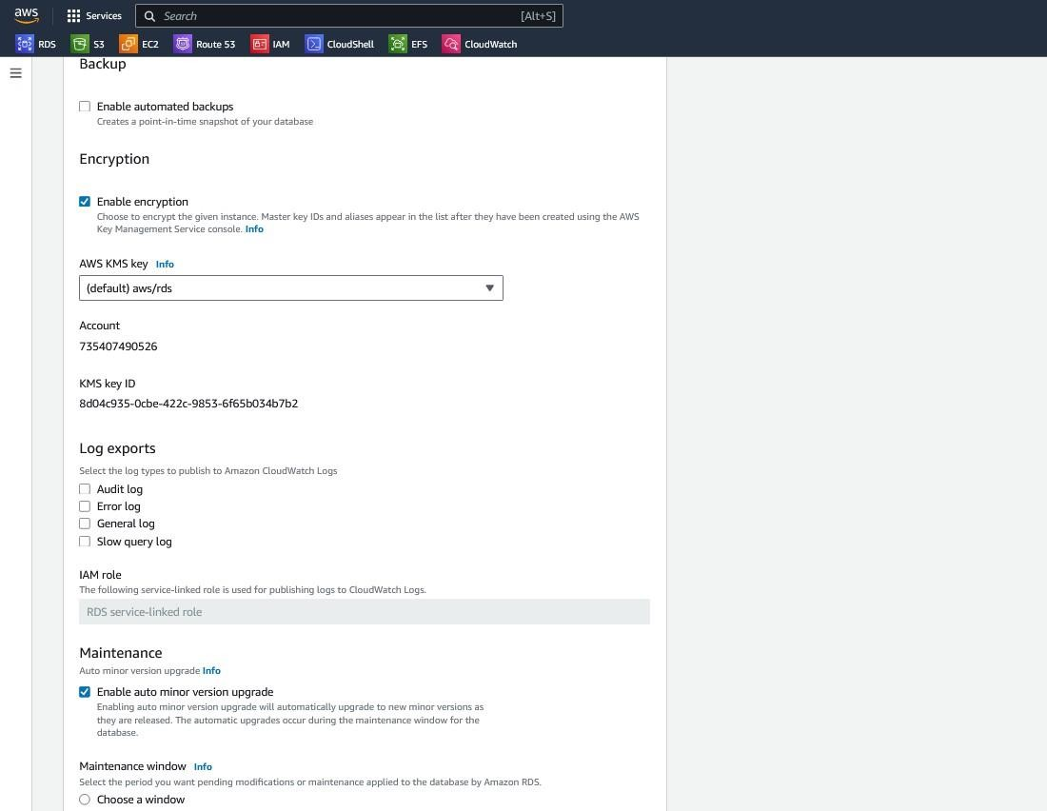

* + ***I have selected no specific maintenance criteria, and based on my selections, AWS indicated estimated monthly cost.***
  + ***Enabled monitoring and assigned a default database name, although I will be installing a***

different schema called ‘ClassicModels’ on this MySQL DB.

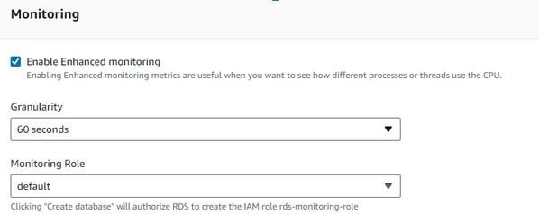

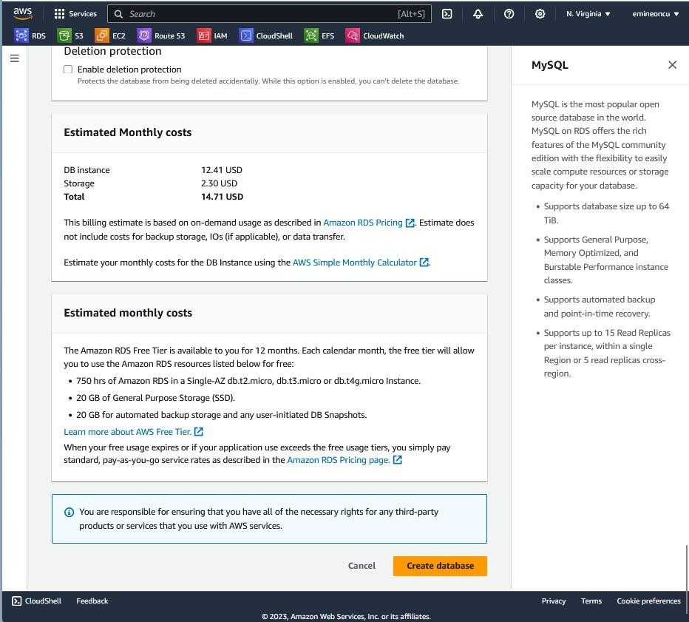

* + ***RDS Instance created.***

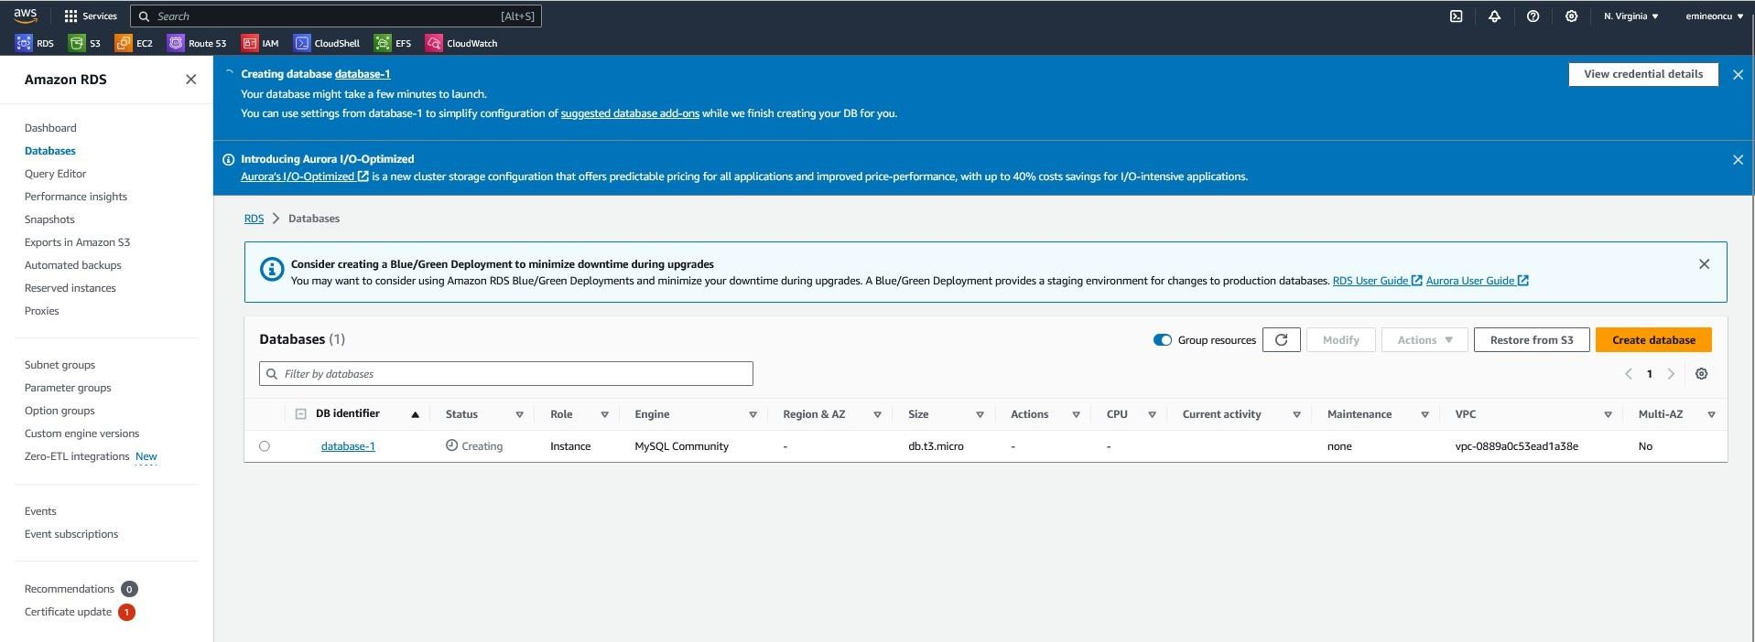

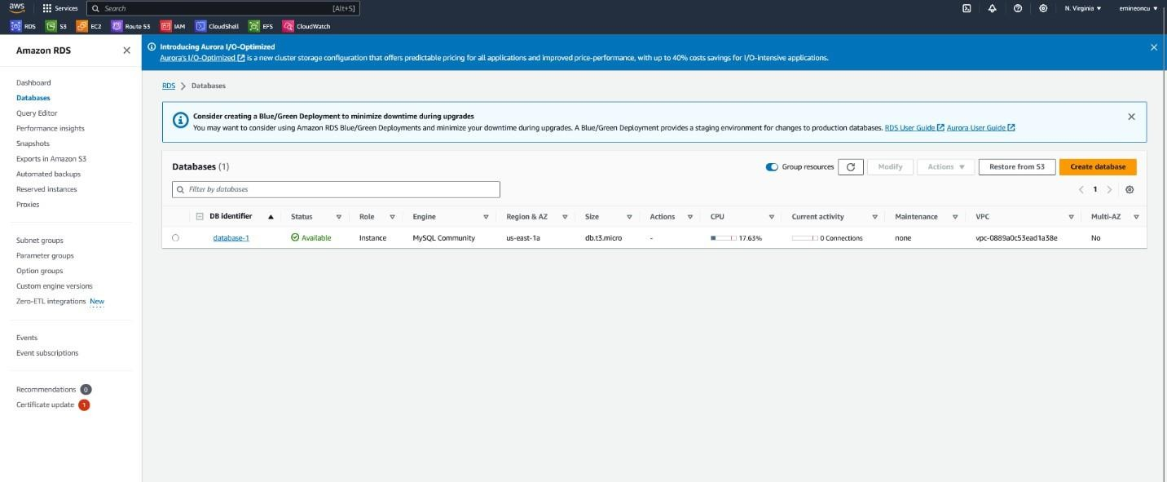

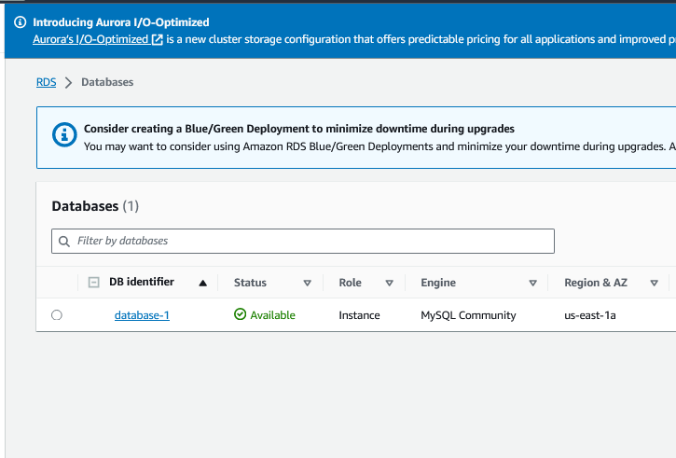

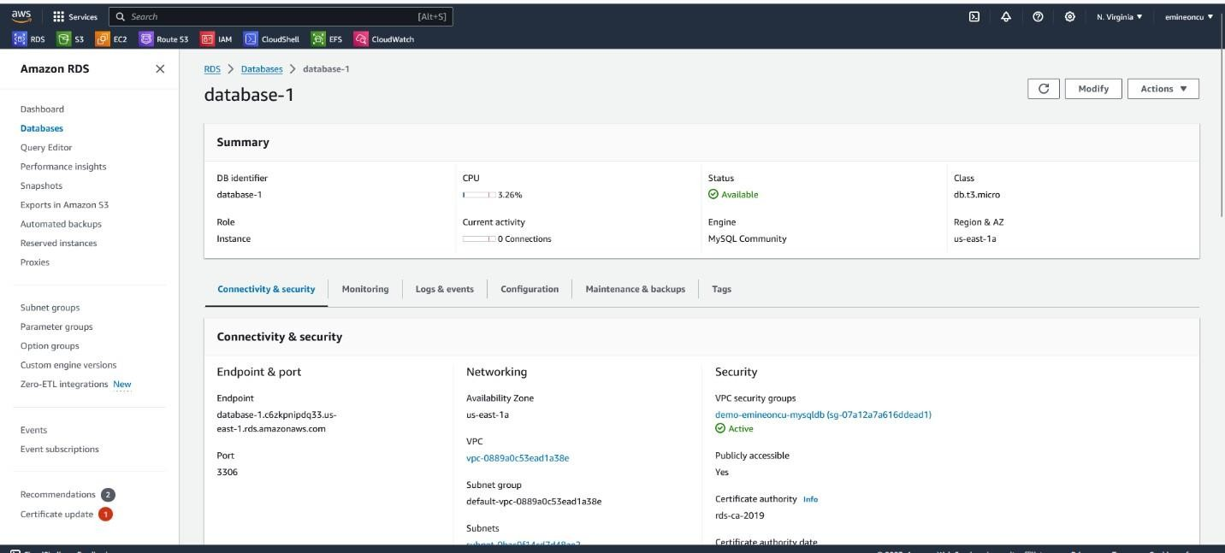

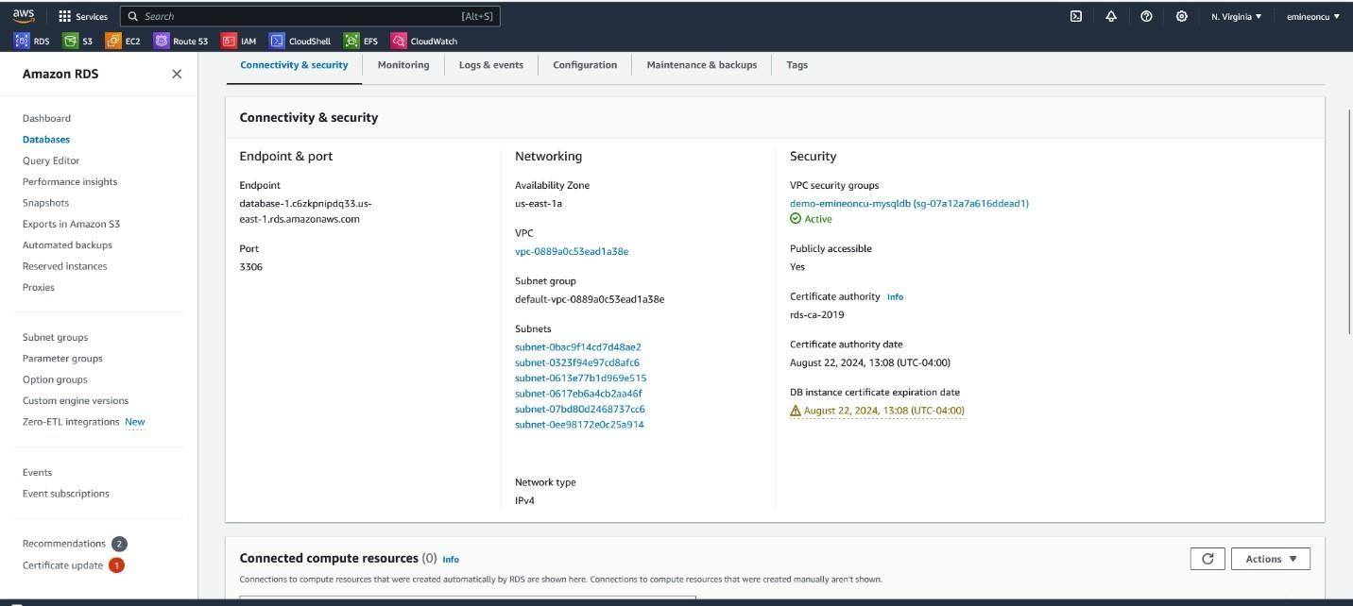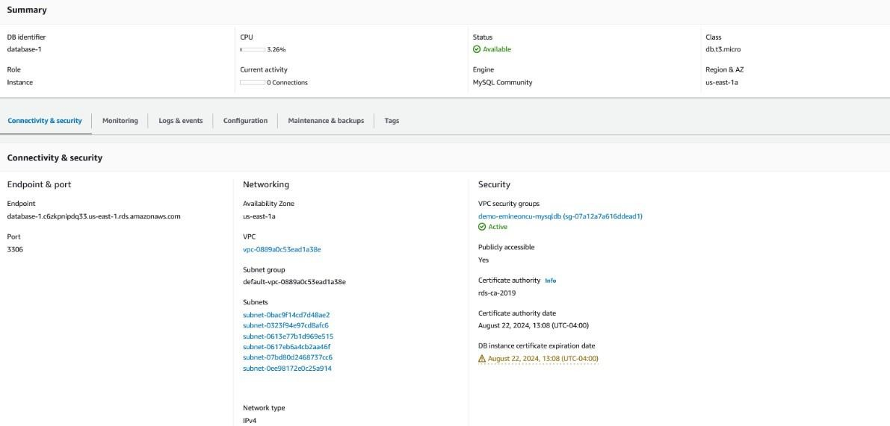

* + ***Connected to MySQL DB in the AWS Cloud from DB Visualizer***

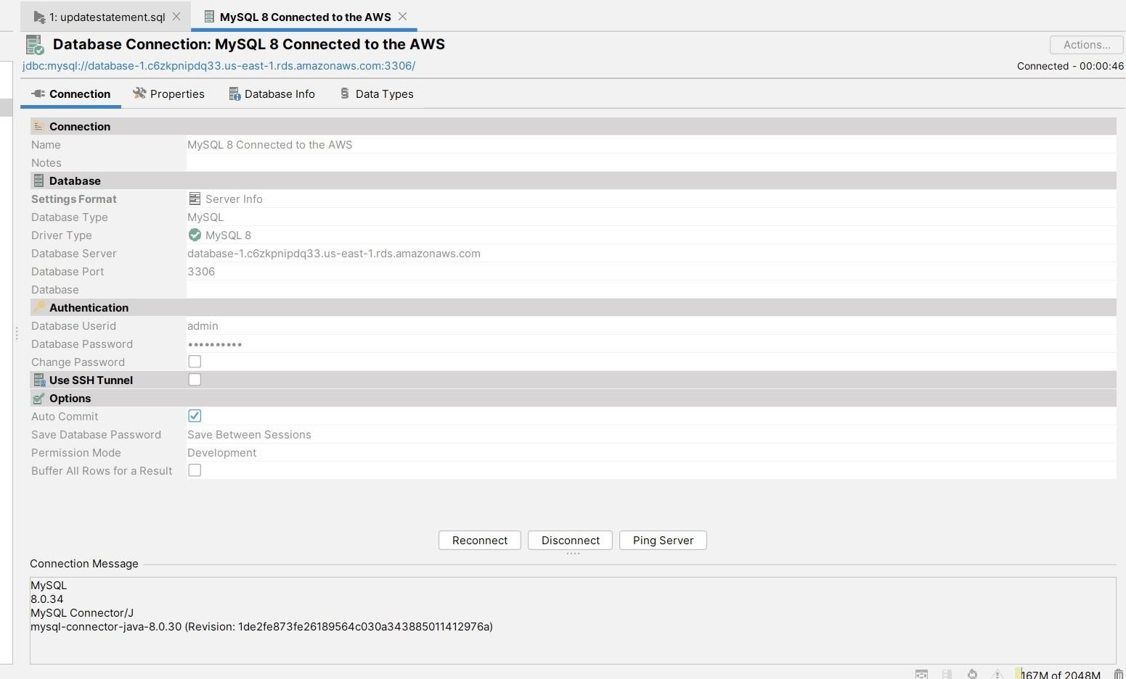

* + ***The default schema which was created at the time of creating the instance is now available.***

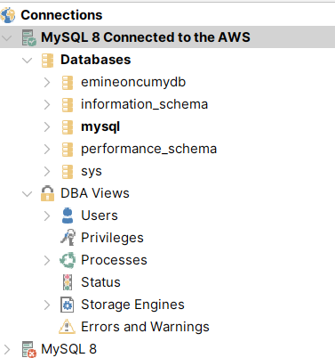

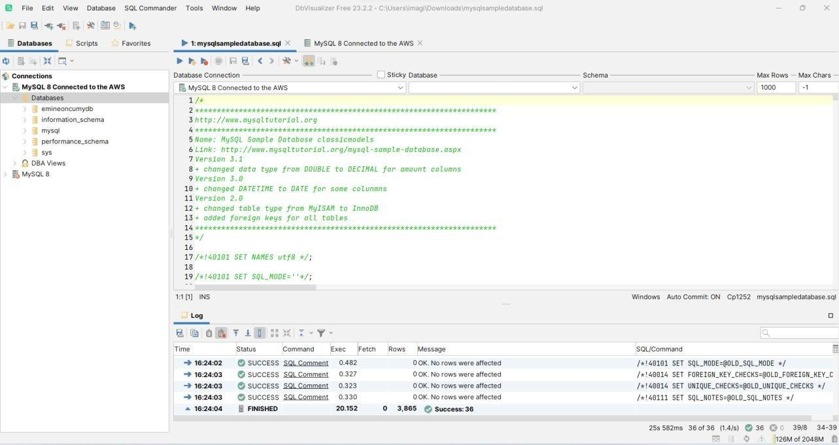

* + ***I have installed ‘ClassicModels’ schema on the MySQl DB running in AWS Cloud***

# ‘ClassicModels’ schema

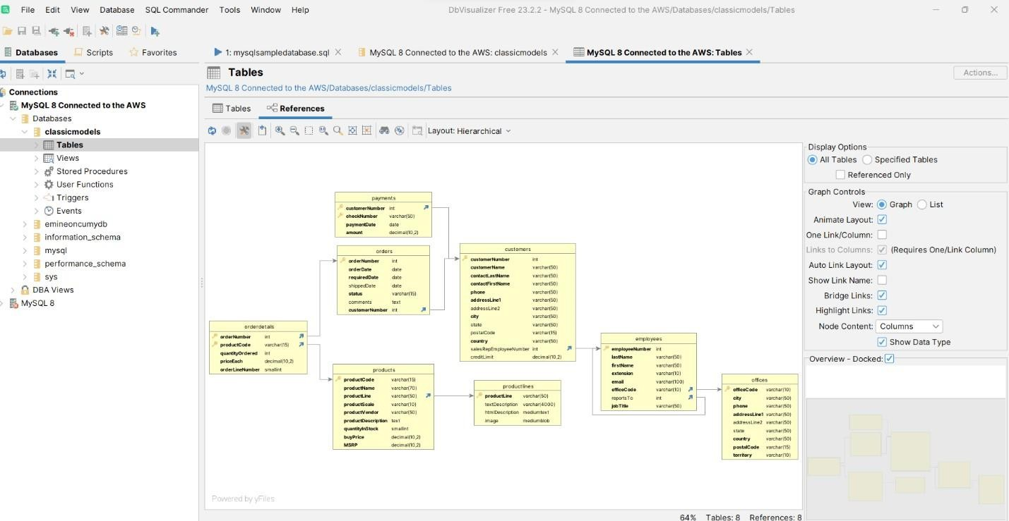

* + ***‘ClassicModels’ schema , Querying the customerNumber ‘121’***

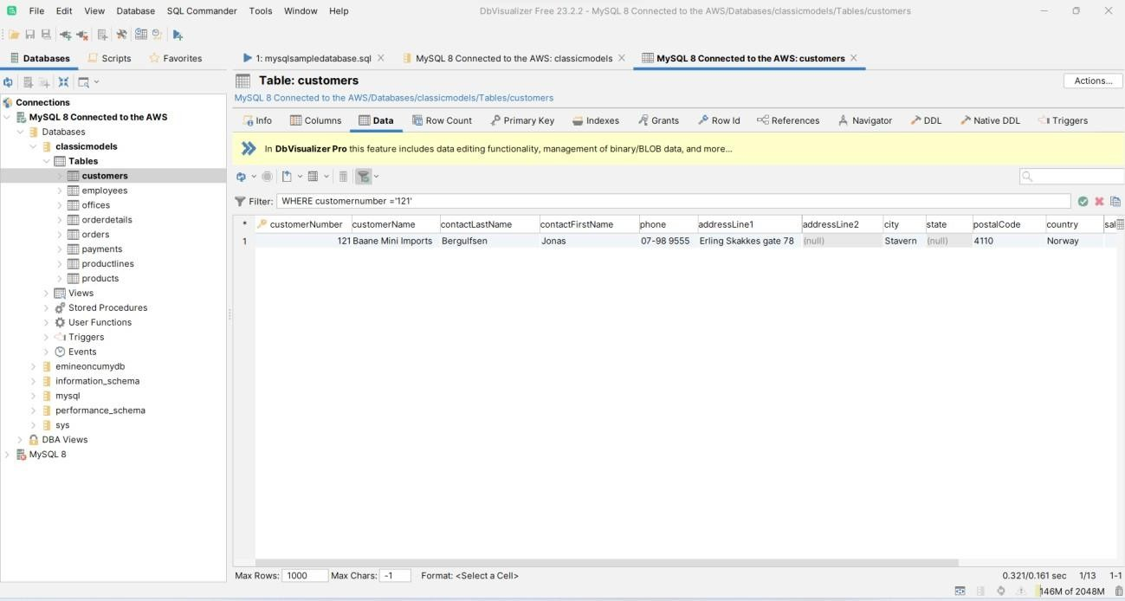

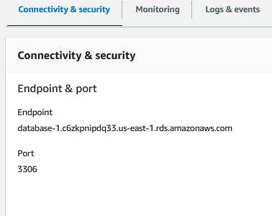**Public DNS Name or Endpoint for my database**

**CRUD operations - Create, Read, Update,**

**Delete Create**

**insert into classicmodels values**

**Read**

**select * from classicmodels where customerNumber ='121'**

**Update**

**Update classicmodels set customerName ='Emine' where customerNumber='121'**

**Delete**

**Delete from classicmodels where customerNumber = '167' Create a DynamoDB table**

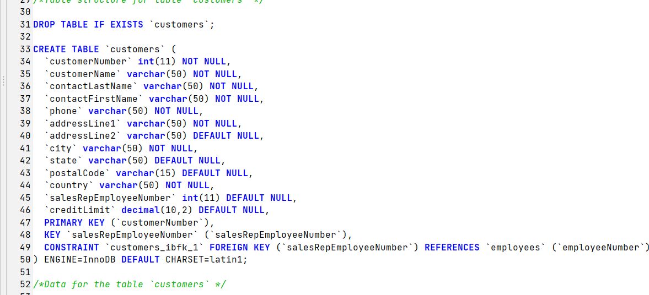

Read

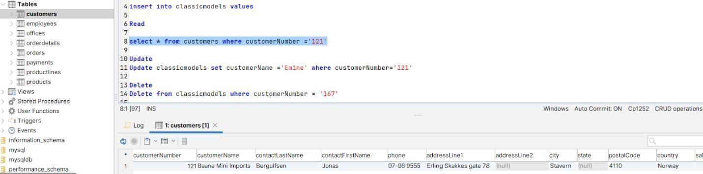

Update

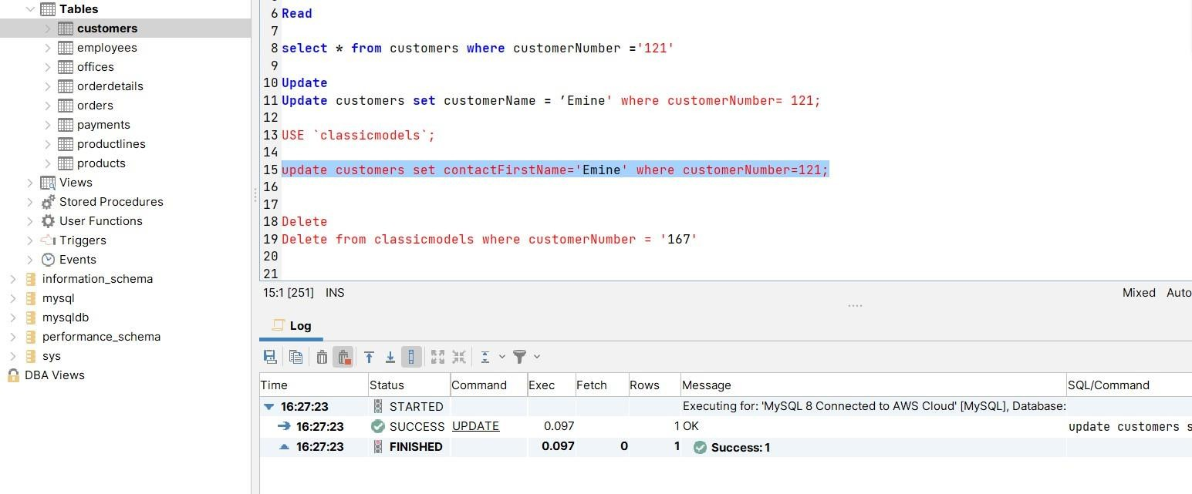

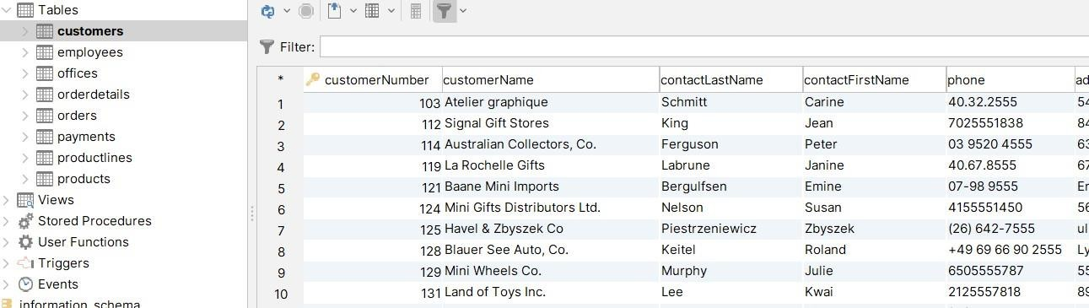

Delete Before delete

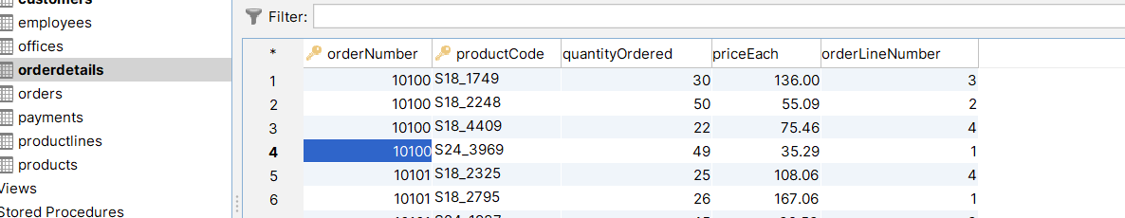

After delete

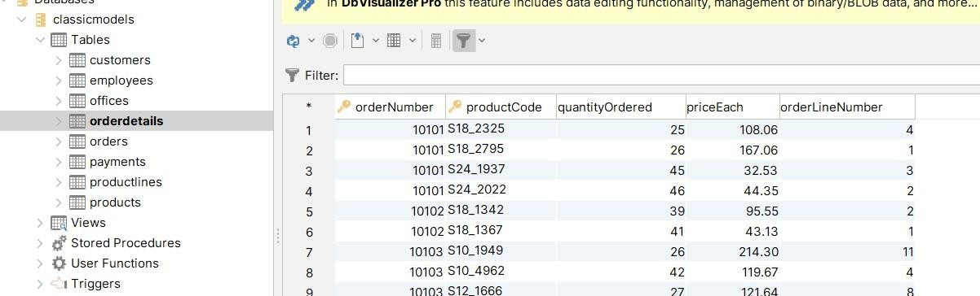

# Create a DynamoDB table

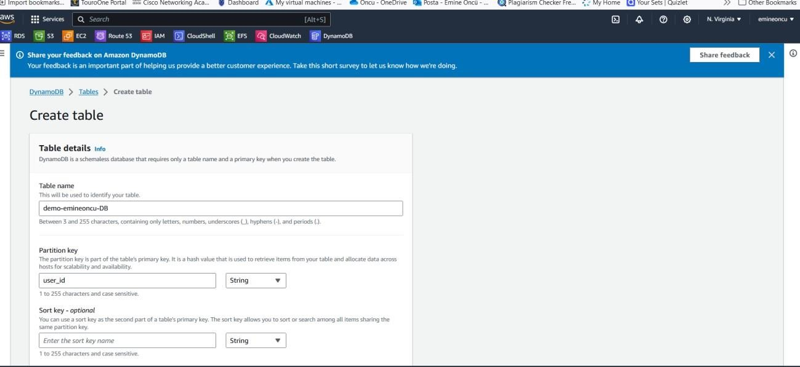

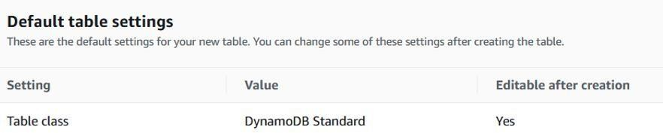

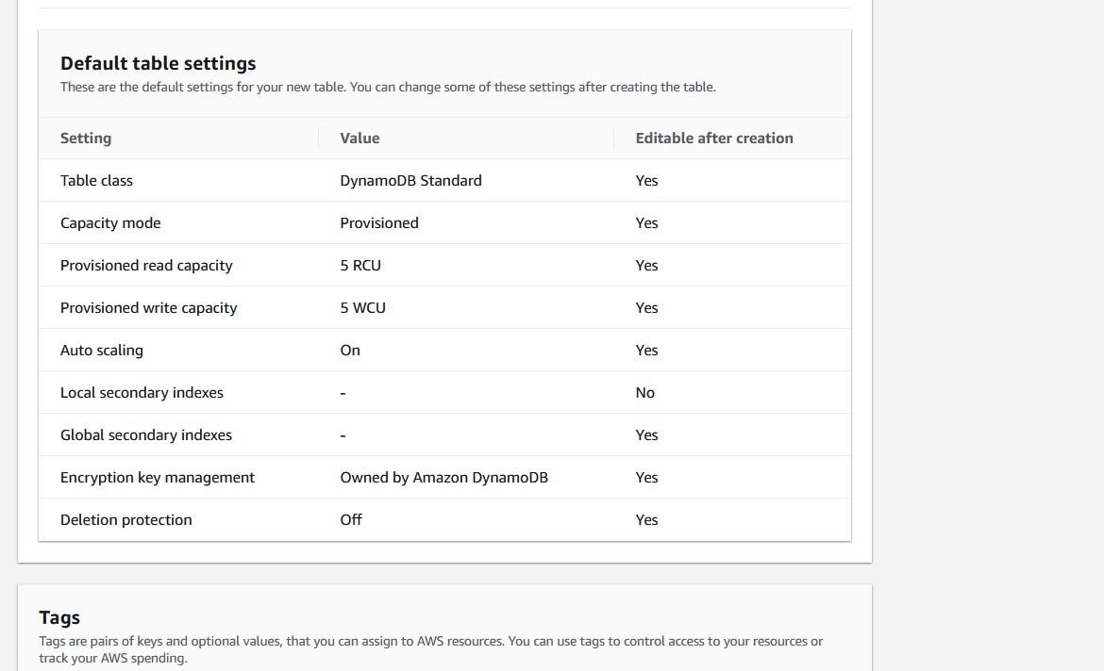

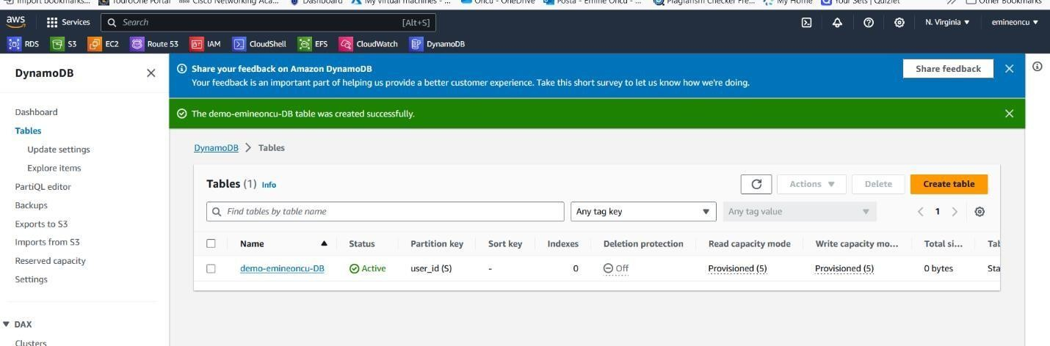

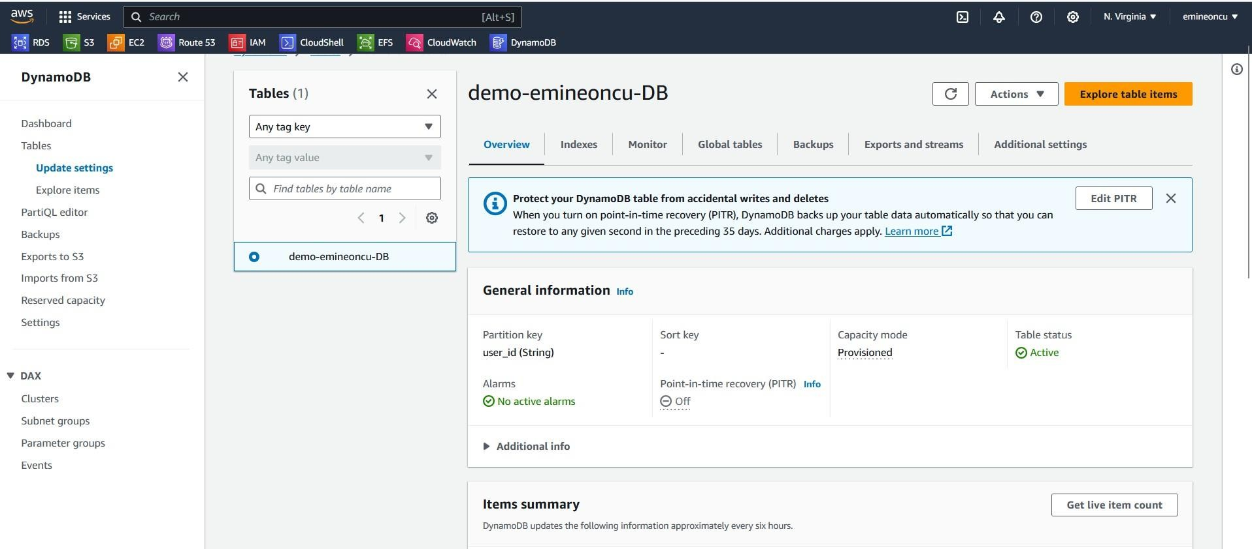

* + ***DynamoDB is serverless, we only create the table and AWS takes care of provisioning the database.***
  + ***Adding an item to the NoSQL DB***

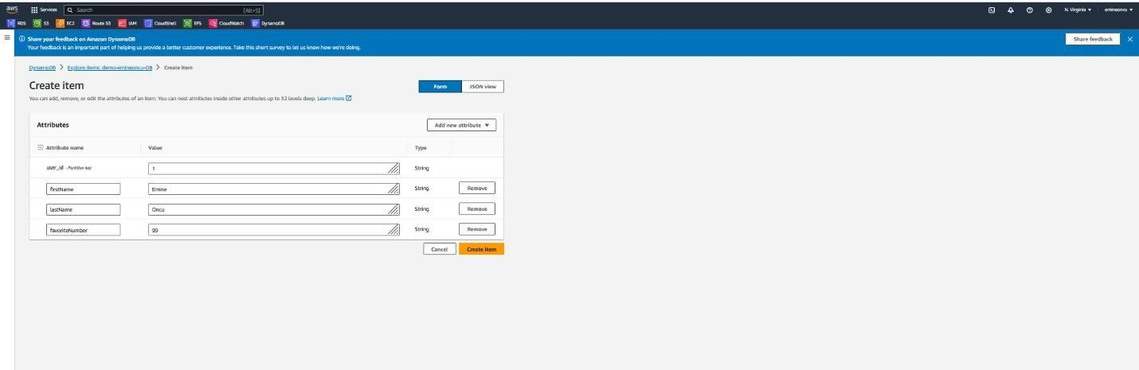

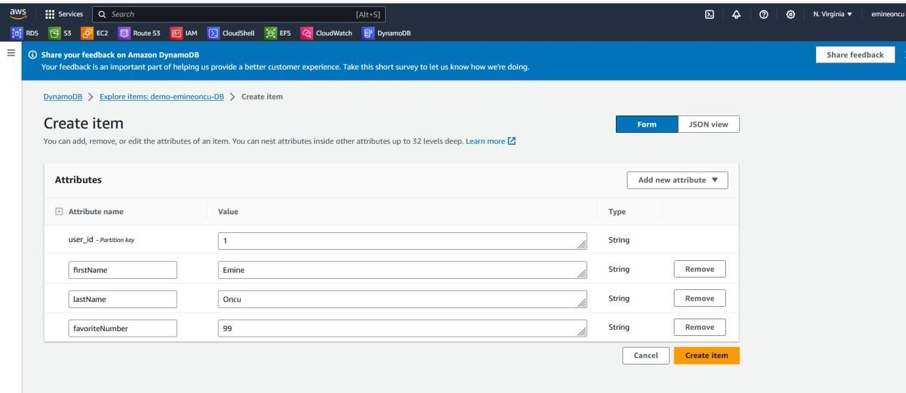

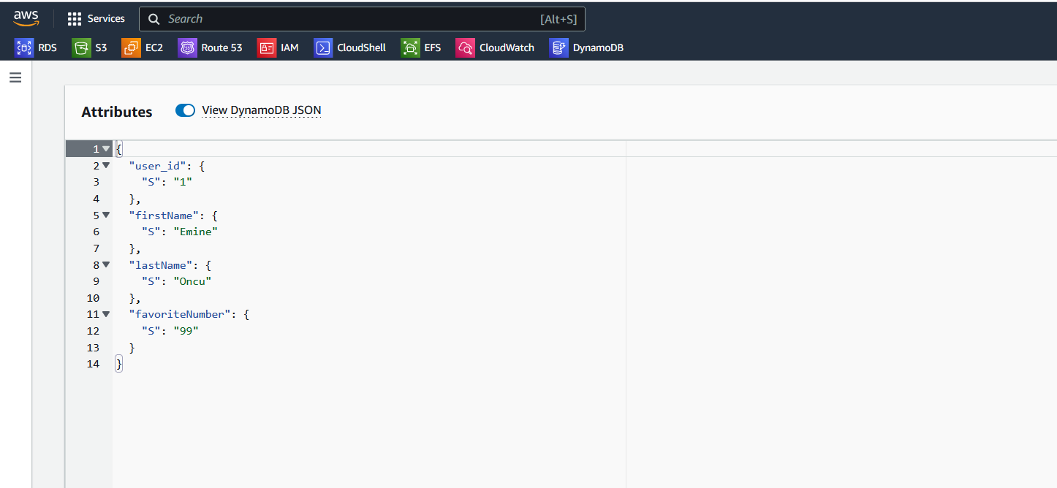

* + ***JSON representation of the item above***

